**Testing**



Testing is define as the activity to check whether the expected result is matched with the actual result or not ***(software-testing-introduction-importance, 2019).*** Software testing generally helps to find out the errors of the program.

There are many types of testing. Some of them are:

1. Alpha testing
2. Regression testing
3. Acceptance testing
4. Black box testing
5. White box testing
6. Unit testing
7. Boundary value testing

But for my project I will only use the 2 type of testing, I.e. Black box and Unit testing.

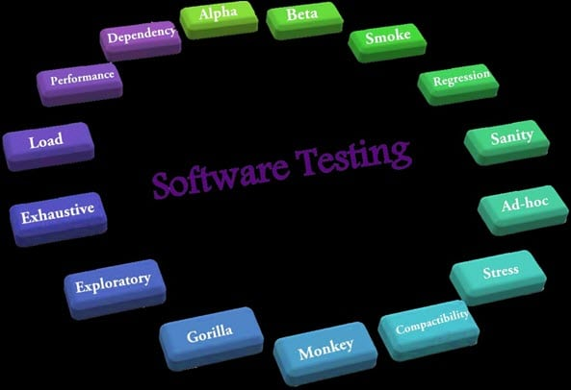

Fig 2: Types of testing

1. **Black Box testing:**

That type of testing in which the internal processing isn't seen but only the input and output is called black box testing. This type of testing is also called the behavioral and eye-to-eye testing.

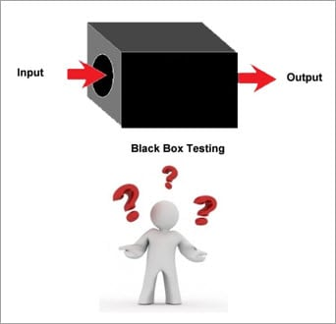

Fig 3: Black Box testing

**Test plan:**

Test plan for black box testing is the document which describes and clarifies about the activities that has been tested. Test plan are of different types. Here is my test cases table of black-box:

|  |  |  |  |  |  |
| --- | --- | --- | --- | --- | --- |
| S.N | Test Case | Test Data | Expected | Actual Result | Date of testing |
| 1 | Registration without filling up the form | Registration Form | Mustn't be register | Register unsuccessful | 6/28 |
| 2 | Registration with filling up the form | Registration Form | Must be register | Register success | 6/28 |
| 3 | Testing phone column with more than 10 digits | Phone column | Mustn't be taken by system | Isn't taken | 6/28 |
| 4 | Testing phone column with exact 10 digits | Phone column | Must be taken by system | Is taken | 6/28 |
| 5 | logging in without password | Password | Mustn't be log in | Isn't log in | 6/28 |
| 6 | logging in with password | Password | Must be login | Login success | 6/28 |
| 7 | Without the correct email | Email | Mustn't be login | Isn't logged in | 6/28 |
| 8 | With correct email | Email | Must be login | Login successful | 6/28 |
| 9 | Logging in with invalid password | Password | Mustn't be login | Login unsuccessful | 6/29 |
| 10 | Logging in with valid password | Password | Must be login | Login successful | 6/29 |
| 11 | Ordering book without filling up the form | Order Form | Mustn't be order | Ordering wasn't success | 6/29 |
| 12 | Ordering book with filling up the form | Order Form | Must be order | Order Success | 6/29 |
| 13 | Book adding by admin without filling the description in form | Admin panel of Posting books | Mustn't be added | Isn't added | 6/29 |
| 14 | Book adding by admin with filling the description in form | Admin panel of Posting books | Must be added | Book is added | 6/29 |
| 15 | Sending message without filling Newsletter form | Newsletter Form | Message Mustn't be sent | Isn't sent | 6/30 |
| 16 | Sending message without filling Newsletter form | Newsletter Form | Message must be sent | Is sent | 6/30 |
| 17 | Without login user can't delete own selves | User Profile | Mustn't be deleted | Isn't deleted | 6/30 |
| 18 | Without login user can't delete own selves | User Profile | Must be deleted | User is deleted | 6/30 |
| 19 | Deleted user can't log in | Login Form | Mustn't be login | Login wasn't success | 7/1 |
| 20 | After Login Chat/Review form appears | Review Form | Must appear | Review form appeared | 7/1 |

Table: Test case Table for Black-box

Here are my all black box testing:

1. Registration form testing with all form filling:

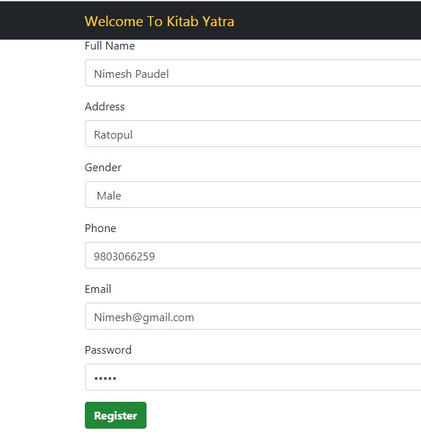

***Fig 4: Registration Form***

After I clicked on registration, User is registered and Login form is shown.

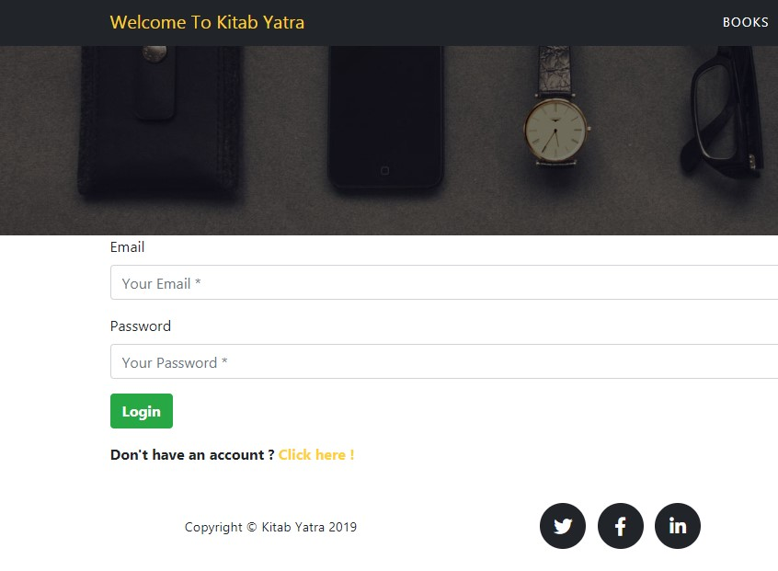

***Fig 5: Login Form***

1. Testing registration form without filling up the form:

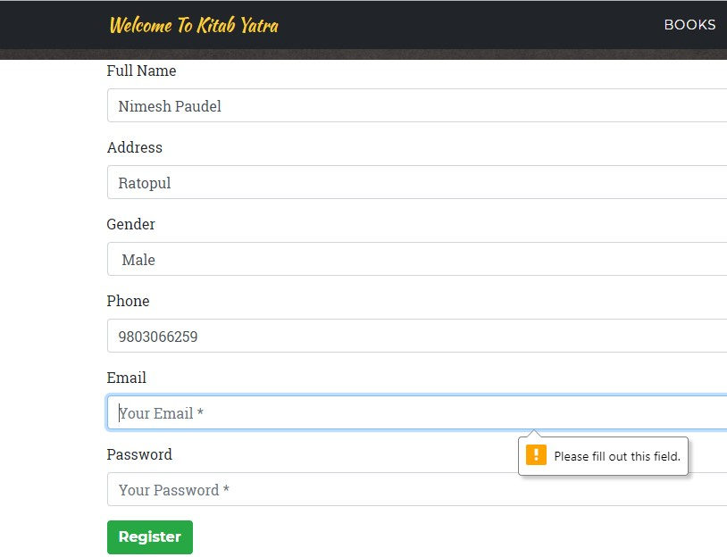

***Fig 6: Registration Form***

1. Testing Phone column with more than 10 digits or less than that:

For the phone number, I have assigned the numeric digits of exact ten. Phone column will give the error message till the phone number will not be exact of length 10. More than 10 or less than 10 will cost the error message.

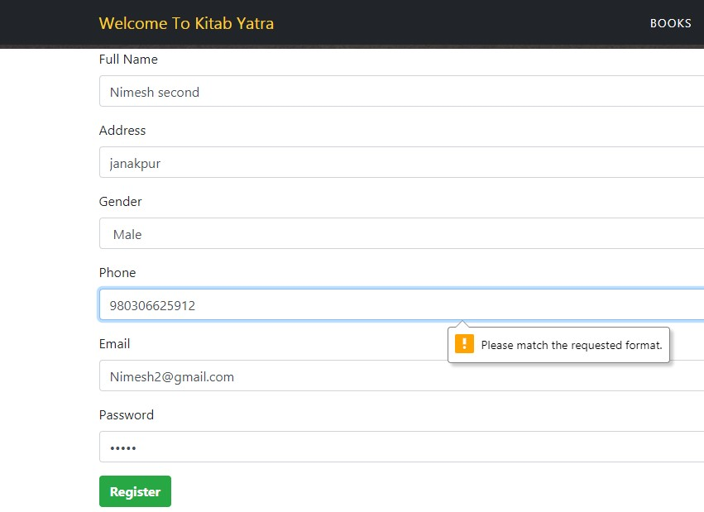

***Fig 7: Registration form for testing Phone column***

4. Testing Phone column with exact 10 digits:

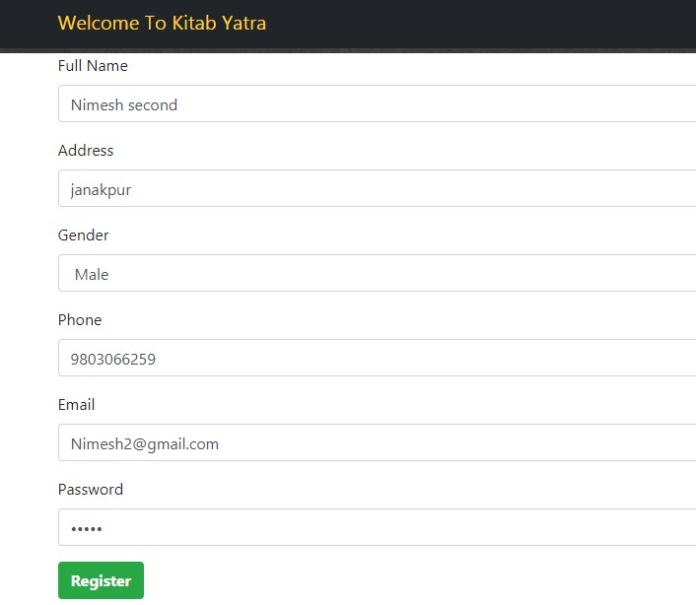

***Fig 8: Testing phone column***

5. Testing Login Form without password

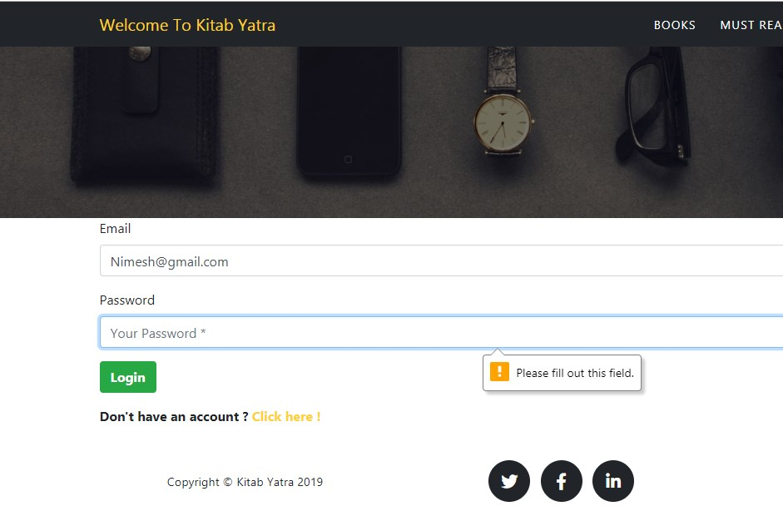

***Fig 9: Login form without password***

6. Testing with Password:

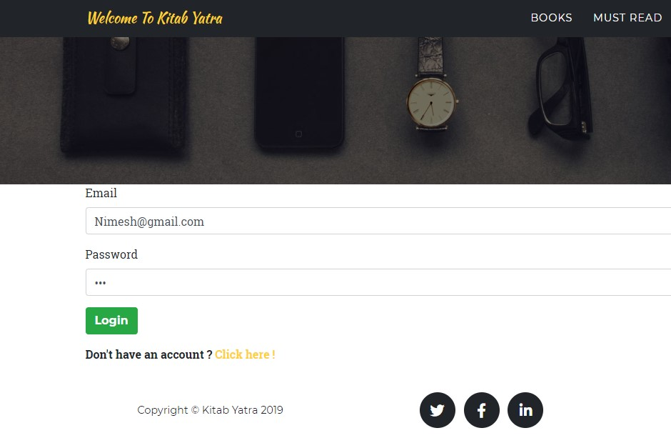

***Fig 10: Login with password***



***Fig 11: Login successful***

7. Login testing with Invalid password

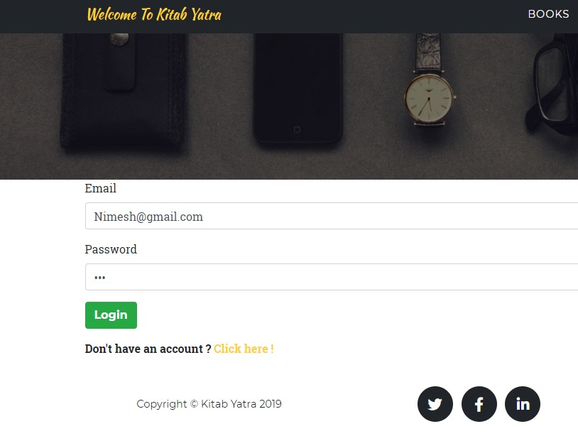

***Fig 12: Invalid Password for login***

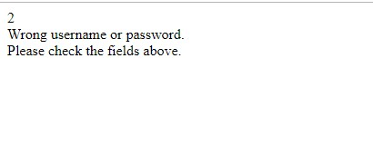

***Fig 13: Error message of login***

8. Login Testing with correct password

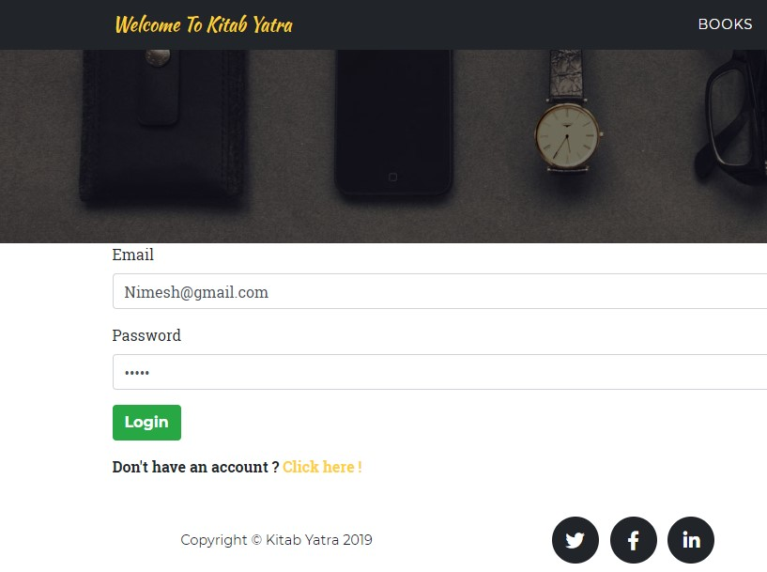

***Fig 14: Login form with correct password***



***Fig 15: Index appears after login success***

9. Login with invalid email

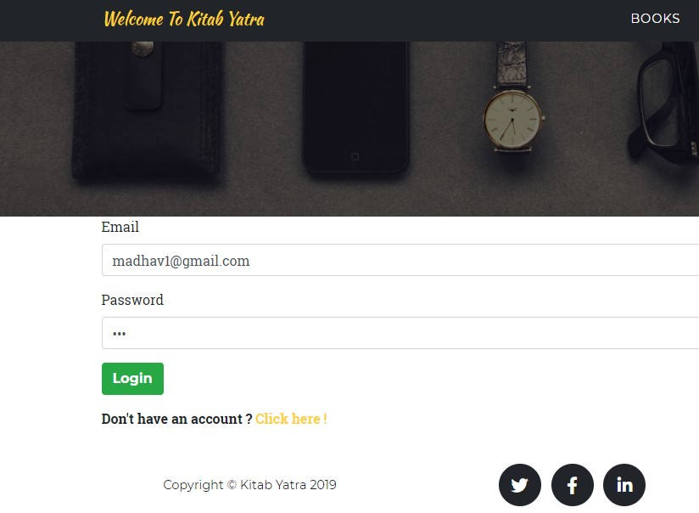

***Fig 16: Login with invalid email***



***Fig 17: Same invalid message appears***

10. Login with correct email

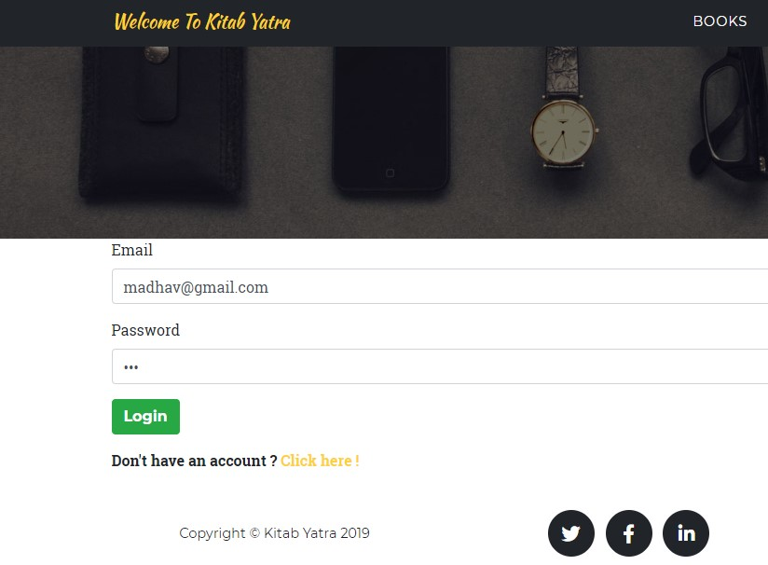

***Fig 18: Login with correct email***



***Fig 19: Index appears***

11. Ordering book without filling up all the form

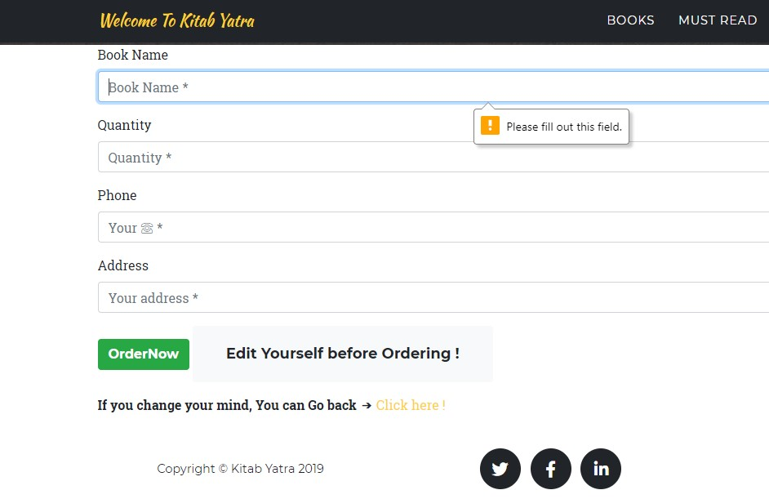

***Fig 20: Order form***

12. Ordering form with filling up the form

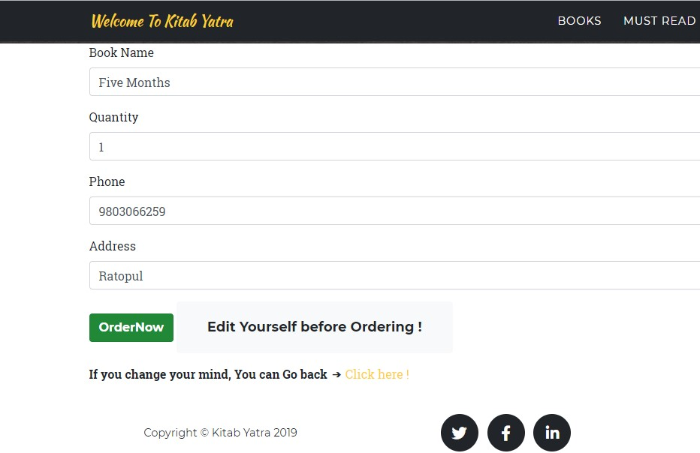

***Fig 21: Filling up the order form***



***Fig 22: After filling up the form and ordering this message appears***

13. Adding book by admin without filling up the form

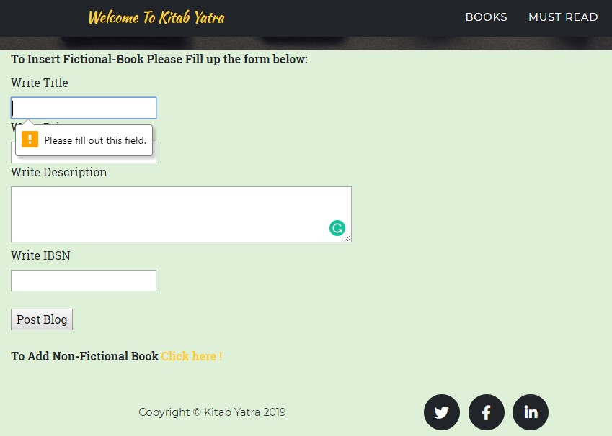

***Fig 23: Admin panel for adding books***

14. Adding book by admin with filling up the form

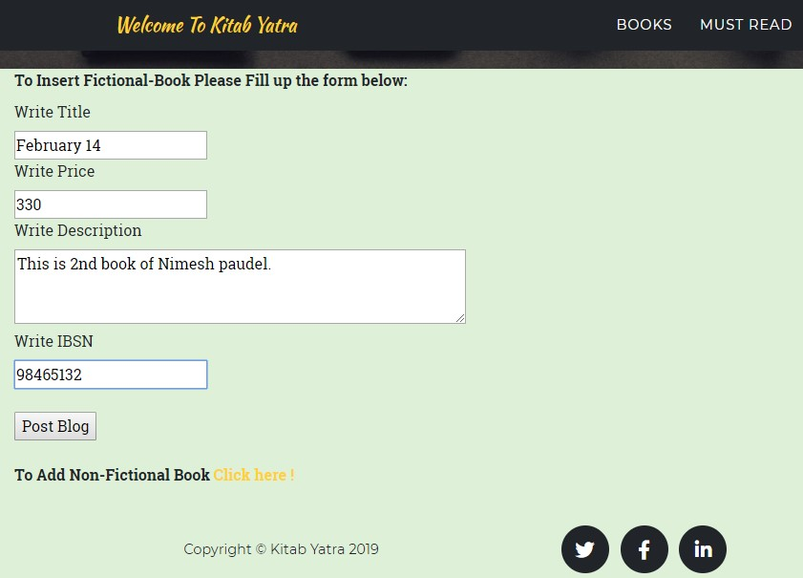

***Fig 24: Filling up form for adding book***

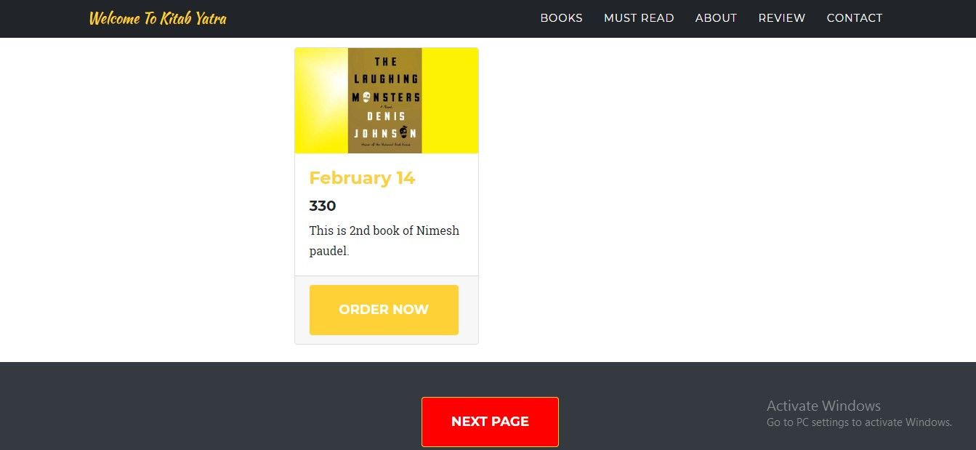

***Fig 25: Book added***

15. Message isn't send unless form is filled for newsletter

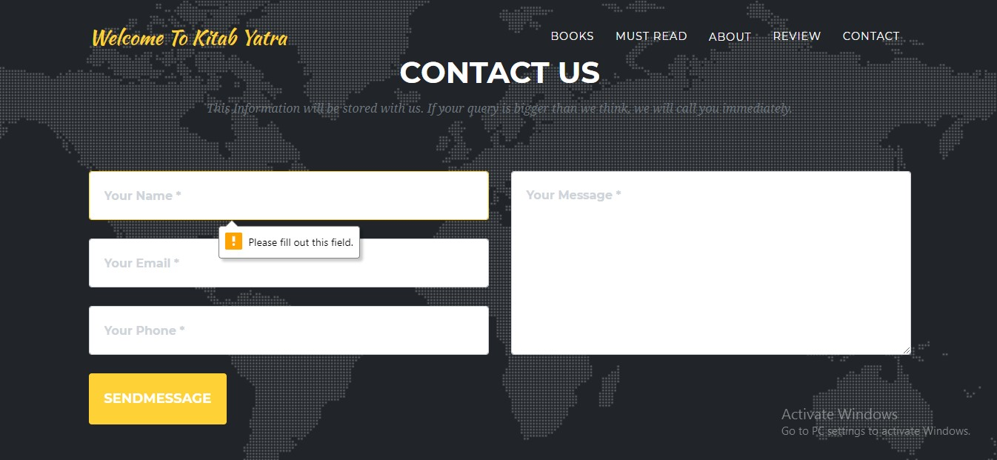

***Fig 26: Newsletter form***

16. Message is sent after the newsletter is filled

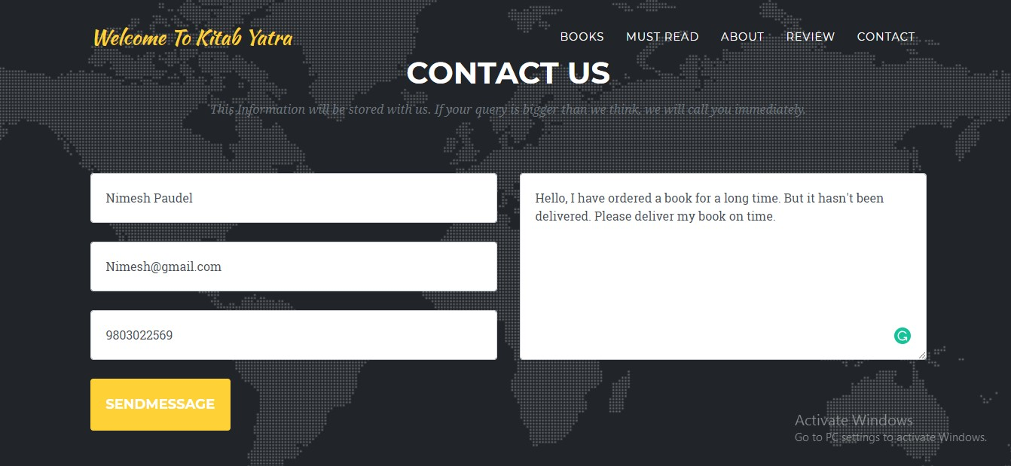

***Fig 27: Newsletter Filled***



***Fig 28: Index appeared after the message is sent***

17. Without login review/chatting with other users isn't possible



***Fig 29: Without login clicking the review will not appear***



***Fig 30: After user click on review login form will appear***

18. After the login review/chatting section appears

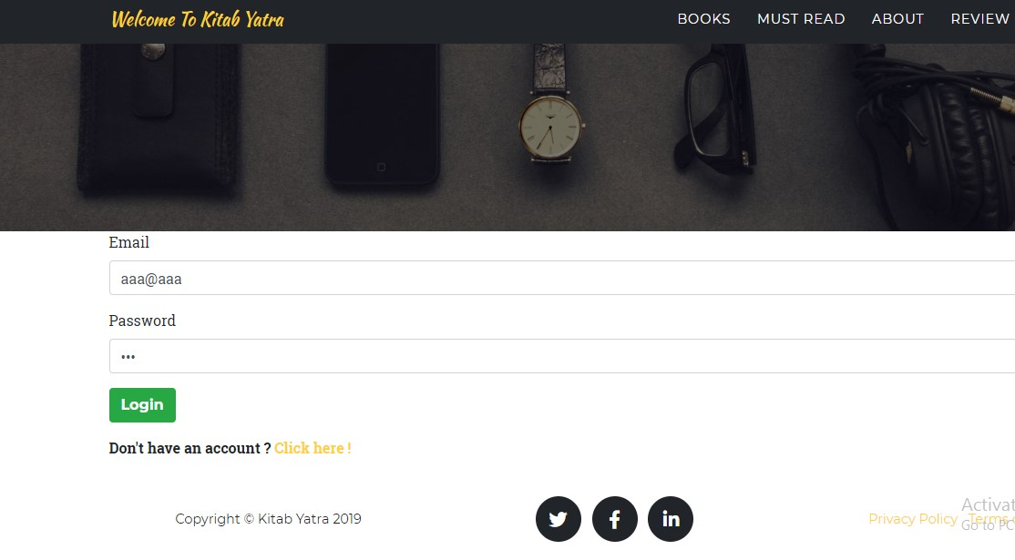

***Fig 31: Login with correct email and password***

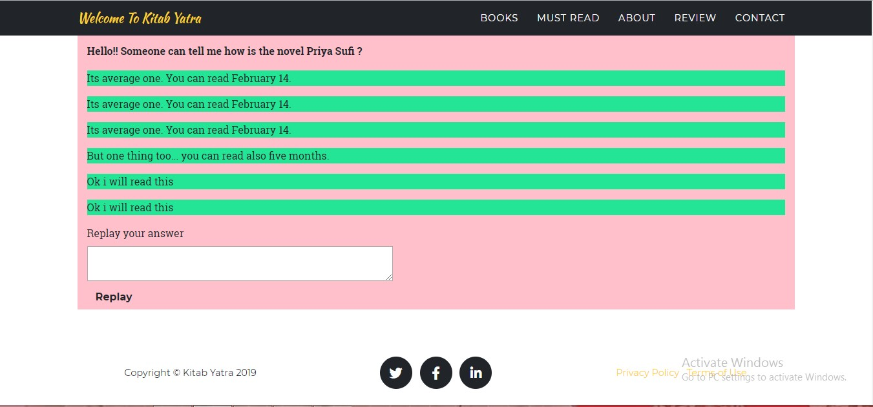

***Fig 32: Review section appears after login***

19. Delete user by own selves

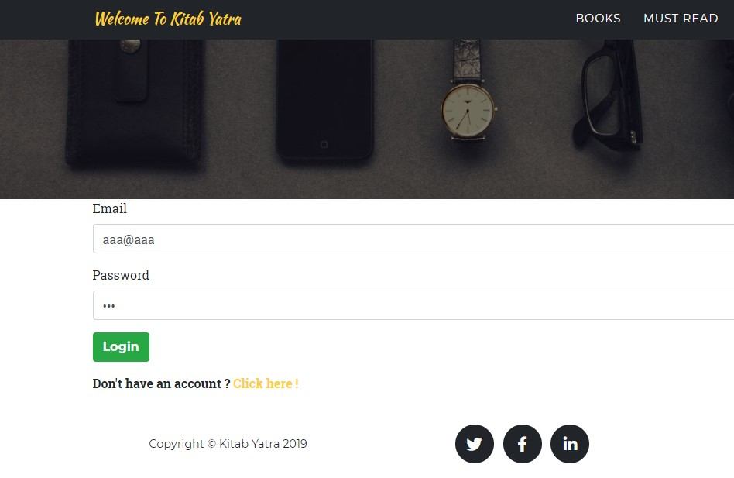

***Fig 33: Login with email "aaa@aaa"***

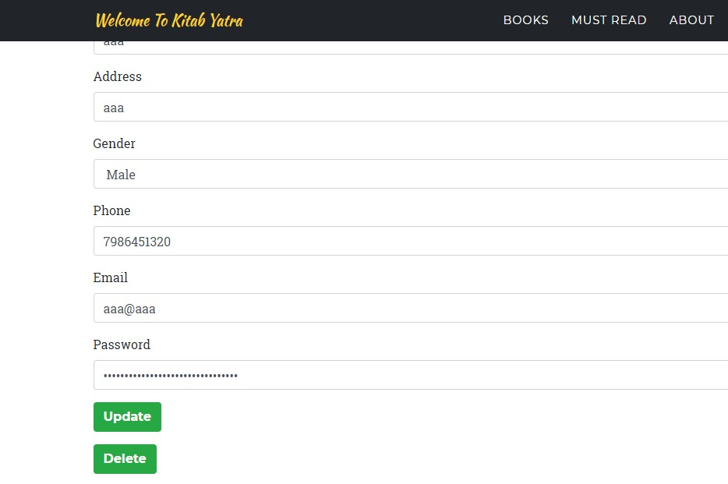

***Fig 34: detail about "aaa@aaa"***

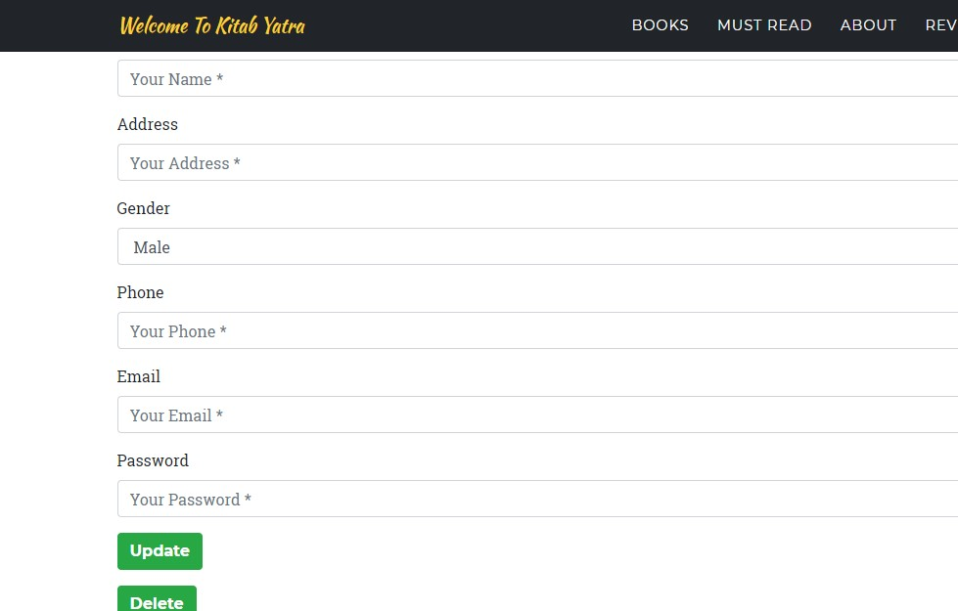

***Fig 35: After Delete button is clicked all data is deleted***

20. Checking the deleted user



***Fig 36: Checking the deleted user with same email and password***



***Fig 37: Error message appeared***

1. **Unit Testing:**

That type of testing in which the individual material or the components are tested is called as Unit testing. This type of testing is done to know whether the each unit of the project is performed as it is designed or not. It is generally performed by the white box testing.

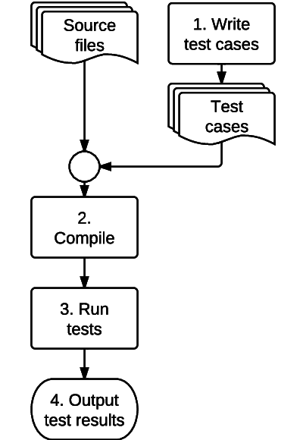

***Fig 38: Unit Testing***